Girl Scout
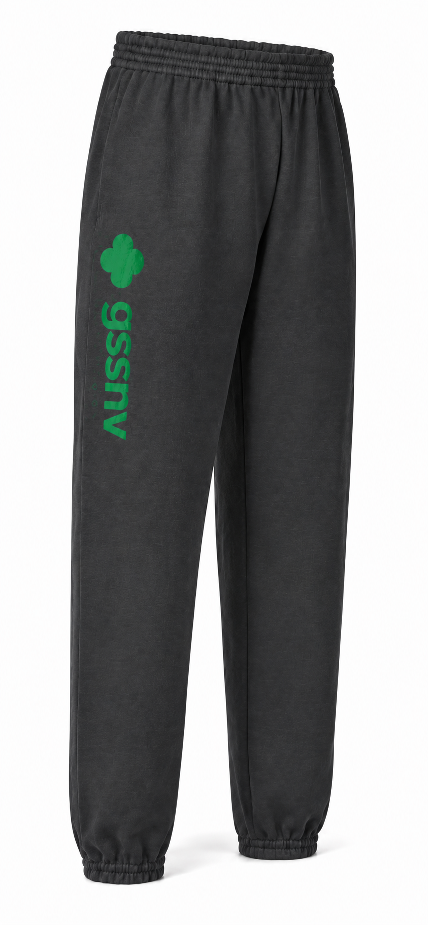
Sweatpants
Stay cozy throughout the 2027 Cookie Program
in Council-branded fleece sweatpants. Made in
dark gray fleece and accented with bold green
GSSNV lettering, they're the perfect blend of
comfort and Council pride.

Preorder November 1, 2026, and save $5.00 off the retail price.
Size | Regular Price | Order by 11/1/26 | Quantity | Total
Youth Small | $35.00 | $30.00
Youth Medium | $35.00 | $30.00
Youth Large | $35.00 | $30.00
Youth X-Large | $35.00 | $30.00
Adult Small | $45.00 | $40.00
Adult Medium | $45.00 | $40.00
Adult Large | $45.00 | $40.00
Adult X-Large | $45.00 | $40.00
Adult 2X-Large | $50.00 | $45.00
Adult 3X-Large | $50.00 | $45.00
Adult 4X-Large | $50.00 | $45.00

Name:_______________________________________________ |  |  | Phone:____________________
Email:____________________________________________________________________________
Address:_____________________________________________ |  |  | Zip Code:__________________
Office Use:
Date Received _______________________________________ |  | Date Called ___________________________
Card Number ___________________________________________________________________________________
Exp Date _________________________ CCV ________________________ |  |  | Zip ___________________________

